SYSC 5104 – Methodologies for Discrete Event
Modeling and Simulation

Assignment #2

Tania Pendergast
100746561
Carleton University

August, 2008

PART 1 – Literature Review and Conceptual Design

The real system that I was intent on modeling and simulating was that of clearing a minefield using robots. A search of the Cell Spaces literature produced very little in the way of examples to guide this assignment. A chance search of Google Scholar located a paper that dealt with an immunity-based search algorithm for peer-to-peer networks [1]. Within this paper, reference was made to the fact that their application of immunity-based concepts had also been used in some initial work on searching for landmines using robots. I located this reference and found that it was not in an IEEE or ACM type publication , but rather was in an article from the journal Nature [2]. Further efforts to locate more in-depth references yielded rather complicated and non-cell space type literature that was not particularly useful to this assignment [3-5]. A key point was made in the Nature article regarding the search of a minefield using robots, and I used this point to guide my conceptual design. This key point was that the:

“robots initially patrol the minefield randomly. When one discovers an area with a concentration of mines, it broadcasts a signal to the other robots, some of which migrate to the area....Only those in the vicinity of the signalling robot are recruited, while farther away robots continue to monitor other parts of the minefield. This simple mechanism easily outperforms traditional ‘raster’ scans, which divide a search area into a grid and comb it cell-by-cell, row-by-row. [2]”

I borrowed from this key point in the formulation of my conceptual design. Rather than create a design that involved cell-by-cell, row-by-row search of the minefield, I created a design that involved the random movement of the robots throughout the minefield. Initial versions of the implementation of my design involved attempts at both collision avoidance and intelligent search.

By intelligent search, I mean that I had hoped that the robots would chose to move in the direction of an unmapped cell in its neighbours rather than move to an already mapped cell. This design presented a myriad of problems that proved too difficult to resolve with my troubleshooting abilities . The intelligent search worked extremely well with one robot, but did not scale well beyond that. As a result, the robots in my design simply move randomly and do not intelligently search their neighbours.

My design incorporates a degree of collision avoidance. I had attempted to account for all possible collisions however the simulations later proved that I had not done so. The robots were designed to move away from robots that are found in their path, however deadlocks occur when a robot is found to be fully surrounded by other robots. Further work would be required to develop more robust collision avoidance rules.

The final conceptual design may be described as follows:
- There is a minefield with mines scattered throughout it. Robots are to be used to scan the ground and generate a map of the location of the mines.
- The robots are placed in locations throughout the minefield and they begin to move. If a robot is located on a cell that has not yet been mapped, it scans the ground and then moves. If a robot is located on a cell that has been mapped, it moves on.
- The robots move randomly about the minefield.
- Only one robot can occupy a cell. If there is a conflict to occupy a cell, the movement of the robots in conflict will change.
- The Cell-DEVS implementation involves the use of a 10x10 minefield with two layers. Layer 1 contains the actual disposition of the mines and layer 0 contains the location of the robots and the map that they are/have generated. The map initially has no cells mapped and the robots are placed about the minefield.
- Once the minefield has been cleared the robots stop moving.
PART 2 – Cell-DEVS Specification

TDC = <X, Y, S, N, type, d, τ, δint, δext, λ, ta>
X = 0, Y = 0
S = {0, 10, 20, 20, 30, 40, 100, 110, 120, 201, 202, 203, 204, 211, 212, 213, 214}

Cell value | Meaning | Layer
0 | Cell mapped - No mine | 0
10 | Cell mapped – Mine | 0
20 | Cell not yet mapped | 0
30 | No mine | 1
40 | Mine | 1
100, 110, 120 | A stationary robot, before decision to move  - 100 denotes a robot on a cell with no mine  - 110 denotes a robot on a cell with a mine  - 120 denotes a robot on a cell that has not yet been mapped | 0
201-204,  211-214 | Robot moving to N(1), E(2), S(3), W(4)  (201-204 denotes that it is leaving a cell with no mine, and  211-214 denotes that it is leaving a cell with a mine) | 0

The palette associated with the cell values defined in the previous table may be found in the file MineClear.pal .
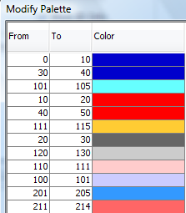

N = extended Von Neumann = {(-1,0,0), (-1,1,0), (-2,0,0), (0,1,0), (1,1,0), (0,2,0), (1,0,0), (1,-1,0),
(2,0,0), (0,-1,0), (-1,-1,0), (0,-2,0), (0,0,0), (-1,0,1), (-1,1,1), (-2,0,1), (0,1,1), (1,1,1), (0,2,1), (1,0,1),
(1,-1,1), (2,0,1), (0,-1,1), (-1,-1,1), (0,-2,1), (0,0,1)}

type = transport

d = 100ms
τ is defined by the following rules:
- if a robot is on a cell that is unmapped (= 120), it scans the ground and picks a new move direction
(= 201-204 if the scan found no mine and = 211-214 if the scan found a mine)
- if a robot is on a cell that is mapped (= 100 or = 110), it picks a new move direction
(= 201-204 if it is on a cell with no mine an = 211-214 if it is on a cell with a mine)
- if a robot has picked a new move direction (= 201-214, 211-214) and there is no conflict with another robot, then it will move to the new cell and clear the former cell
- if there is a conflict with another robot, a new move direction will be selected for one or both robots

λ
- a scan of a cell ( = 120) will output a new move direction based upon whether the cell has no mine (= 201-204) or has a mine (= 211-214)
- an already mapped cell (= 100 or = 110) will output a new move direction based upon whether the cell has no mine (= 201-204) or has a mine (= 211-214)
- a conflict between robots who have chosen their move direction (= 201-204, 211-214) will output new move directions for one or both robots (= 201-204, 211-214).
- the move of a robot from a cell (= 201-204, 211-214) will clear the cell (= 0, 10) and occupy the new cell (= 100, 110, 120). The cell from which it is departing will revert to the mapped value for that cell (ie. mine = 10 or no mine = 0). The new cell will output a value associated with whether it is not mapped (= 120), already mapped with no mine (= 100), or already mapped with a mine (= 110).

ta
- cells in layer 1 have values of 30 and 40. These values do not change since this is the actual disposition of the mines in the ground.
- if a cell is unmapped, the ground is scanned and a move direction is chosen = 200 ms
- if a cell is mapped, the ground is not scanned and a move direction is chosen = 200ms
- if there is a conflict with another robot, their move directions will change = 200ms
- the actual move and the clearing of the former cell occur simultaneously = 200ms
PART 3 – Results And Discussion

The conceptual design was implemented using CD++. Tests were run using 1, 2, 4, 6, and 8 robots to clear the 10x10 minefield. The following table outlines the results that were obtained.

1 Robot | 2 Robots | 4 Robots | 6 Robots | 8 Robots
Location of Robot(s)
(0,0,0) | (0,0,0), (0,9,0) | (0,0,0), (0,9,0),  (9,0,0), (9,9,0) | (0,0,0), (0,9,0),  (9,0,0), (9,9,0), (4,0,0), (5,9,0) | (0,0,0), (0,9,0),  (9,0,0), (9,9,0),  (4,0,0), (5,9,0), (0,4,0), (9,5,0)
Results
100% cleared at 1:24:30:200 | 100% cleared at 14:43:400 | 100% cleared at  3:11:800 | 100% cleared at  3:43:600 | Too many errors encountered. Deadlock at  2:47:200
To view the simulation:
- Click the simulate button.
- Load the appropriate .bat file (listed below) and click Proceed.
- Once the simulation has ended, load the CD++ Modeler.
- Click Animate/Cell-DEVS Animation.
- Add the appropriate .ma and .log files.
- Load the model.
- Load and accept the.pal file (there is only one and it is called MineClear.pal)
MineClear1Robot.bat | MineClear2Robots.bat | MineClear4Robots.bat | MineClear6Robots.bat | MineClear8Robots.bat
MineClear.pal | MineClear.pal | MineClear.pal | MineClear.pal | MineClear.pal

Discussion

My inability to resolve the timing issues associated with implementing an intelligent search capability resulted in my deciding instead to simply implement random movement of the robots (ie. rather than movement to the nearest unmapped cell before movement to an already mapped one). As a result of this implementation design, the robots can be seen to spend an inordinate amount of time simply wandering in circles and not mapping the unmapped cells, despite the potential existence of unmapped cells around them. With an intelligent search capability, the mapping of the entire minefield would certainly be much quicker. I believe that the reality of clearing a minefield with robots would be that they would have an intelligent search capability, however I was unable to implement it properly.

I believe that the increase in mapping time from 4 to 6 robots is likely due to the fact that the conflicts between robots hindered their ability to move freely. Results with these numbers of robots in a larger grid would likely reduce this problem. This issue raises the point that there is likely an ideal number of robots to use for certain sized grids. Either that, or superb collision avoidance algorithms beyond my simple implementation would be required.

Once I reached the use of 8 robots to clear the 10x10 grid, the robots became too congested in the minefield and my collision avoidance rules no longer sufficed to allow them to continue moving. Robots encountered conflict with multiple other robots and ceased to move around the minefield. This problem indicates that either more robust collision avoidance rules, taking into account conflicts with multiple other robots, would be required. Either that, or an ideal number of robots exists, and that beyond this number, the mapping ability of the robots is degraded. It may also be a combination of these two concepts in addition to others that did not present themselves during my simulations.
Future Work

This model and accompanying simulations are by no means complete. Future efforts to improve this work could be focused on the following areas as a minimum:

- In order to accomplish a working model, the intelligent search capability of the robots had to be discarded. This should be added in future as it will significantly lessen the unnecessary wandering of the robots.
- The collision avoidance rules must be further improved in order to allow for the resolution of conflicts with more than one robot.
- The use of one or multiple robots to map a minefield should be tested on different sized grids. It may be that a combination of an ideal or appropriate number of robots with robust collision avoidance rules would prevent the deadlocks similar to those that I experienced in the simulation that employed 8 robots to map the 10x10 grid.
- The simulations should be run to test the effects of different initial placements for the robots on the minefield. My simulations were only run using initial placements in the outer corners and along the outer borders of the minefield. This may be all that is safe to consider since the minefield has not yet been mapped and personnel would not be free to move about the minefield in order to place the robots.

Graphical Displays
1 Robot
At Start:
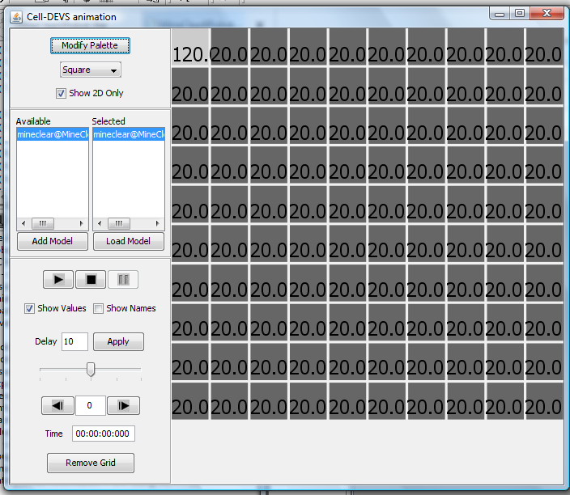

At 1:24:30:200. 100% cleared.
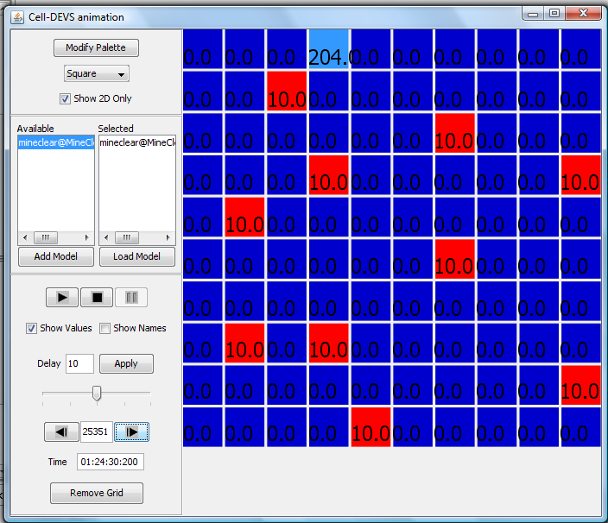
2 Robots
At Start:
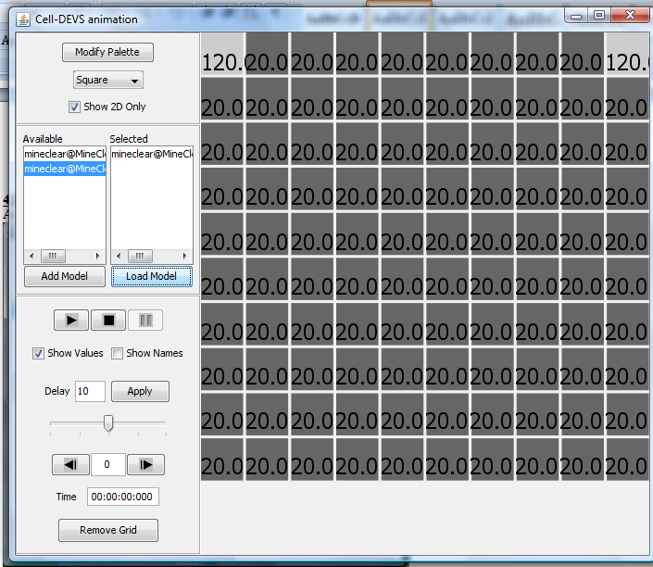

At 14:43:400. 100% complete:
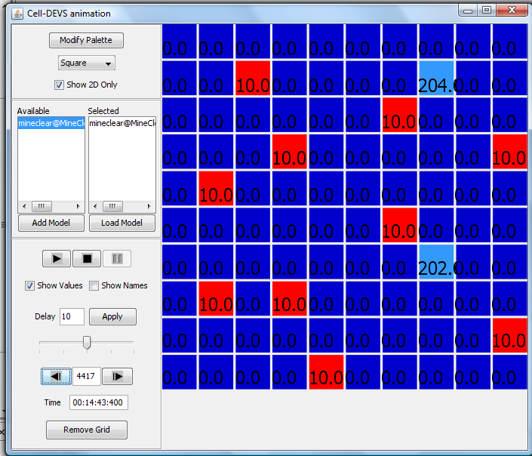
4 Robots
At Start:
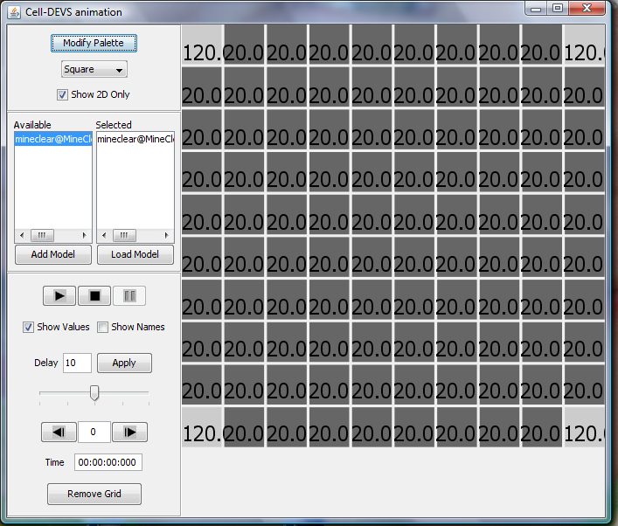

At 3:11:800. 100% complete.
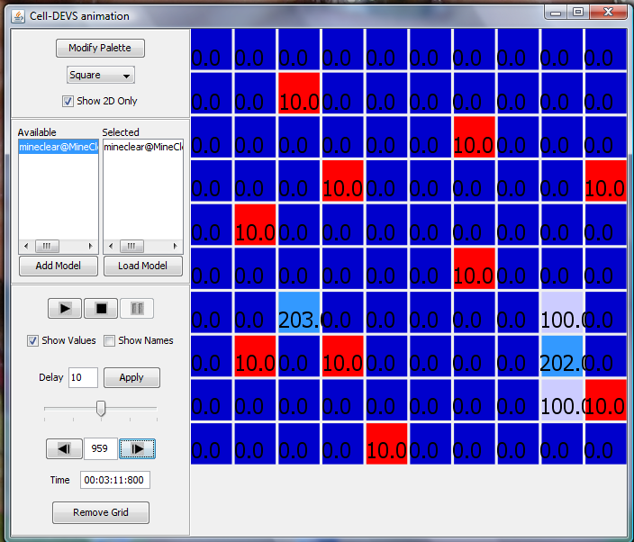

6 Robots
At Start:
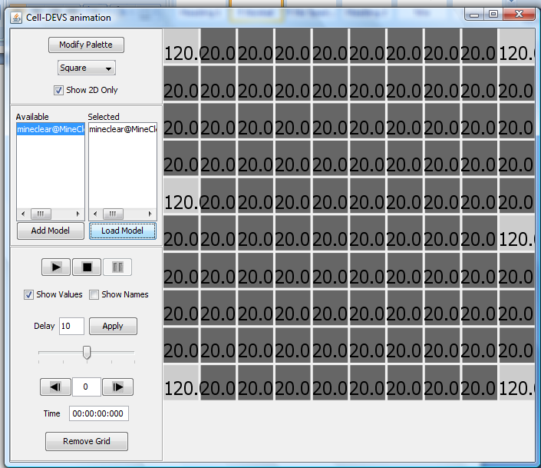

At 3:43:600. 100% complete.
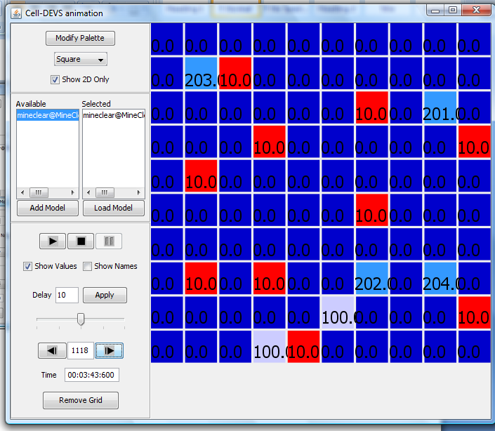
8 Robots
At Start:
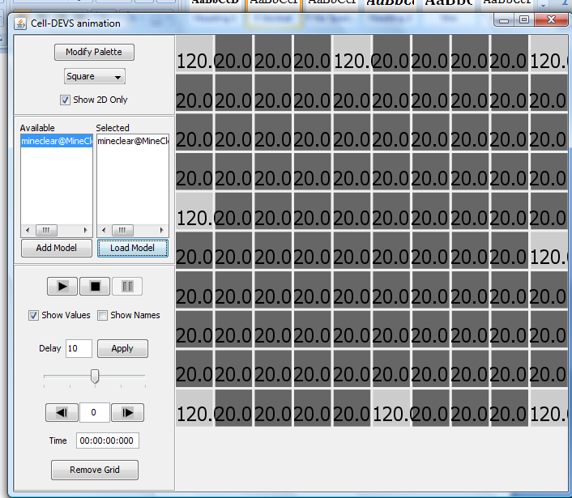

At 2:47:200. Deadlock at 99% complete. All robots can no longer move.
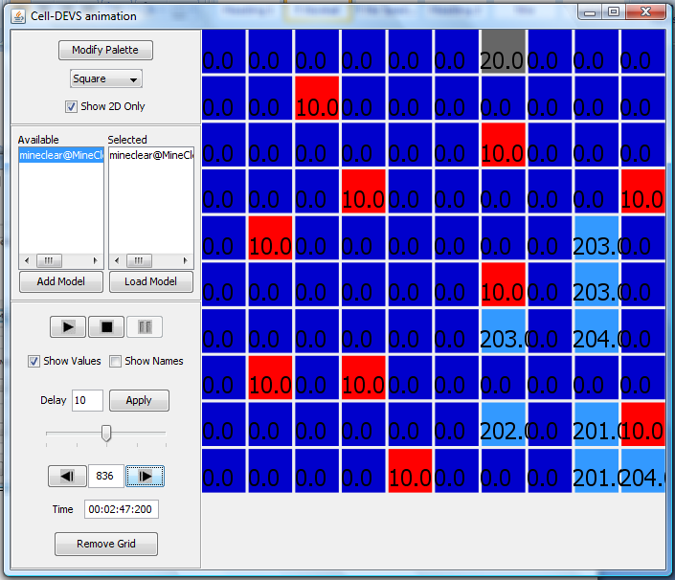
References

[1] N. Ganguly and A. Deutsch, "A Cellular Automata Model for Immune Based Search Algorithm," in Proceedings of the 6th International Conference on Cellular Automata for Research and Industry, Amsterdam, Netherlands, 2004, pp. 61-70.
[2] E. Klarreich, "Inspired by Immunity," Nature, vol. 415, pp. 468-470, 31 January 2002.
[3] A. C. Morris, S. P. N. Singh, and S. M. Thayer, "Development of an Immunology-Based Multi-Robot Coordination Algorithm for Exploration and Mapping," Conference on Intelligent Robots and Systems, Presentation, October 2, 2002.
[4] S. P. N. Singh and S. M. Thayer, "A Foundation for Kilorobotic Exploration," in Proceedings of the 2002 Congress on Evolutionary Computation, 2002.
[5] S. P. N. Singh and S. M. Thayer, "ARMS: Autonomous Robots for Military Systems - A Survey of Collaborative Robotics Core Technologies and Their Military Applications," Carnegie Mellon University Robotics Institute, CMU-RI-TR-01-16, 2001.

